As you know we will be installing over 700 metres of pipe to divert the Longbenton Letch out of the sewer network, improving the performance of our sewer network. This work will involve installing new surface water pipes in the Benton Cemetery, Benton Green and across the playing field of Longbenton Community College.

Our progress to date is summarised in the following table:

AREA OF WORK | PROGRESS REPORT (as of Friday 2 November 2016) | COMPLETE (%)
Benton Cemetery | We have installed the transfer pipeline from the large screening structure in the cemetery and along into Benton Green. This required some tree felling along the pipeline route whilst maintaining access to the Green and the cemetery at all times.  Work is progressing well and reinstatement works are due to start in November 2016 but this is weather dependant | 80%
Works in Longbenton Community College – lay surface water pipe, create attenuation basin, re-profile playing fields | We have installed a new outfall at the rear of the playing field and laid the new diversion pipeline through the playing field and out into Benton Green. We have also created the new surface water attenuation basin at the rear of the playing field. We need to lay the top soil, however seeding won’t start until Spring 2017.  Works are on programme. | 80%
Works at Benton Dene School Car Park and Benton Green | We have completed the pipeline across Benton Dene Primary School car park on target, working within the school holidays to ensure the school was able to open without any disruption.  We will be commencing reinstatement work on The Green in November 2016 which will be completed in Spring 2017. | Car Park 100%
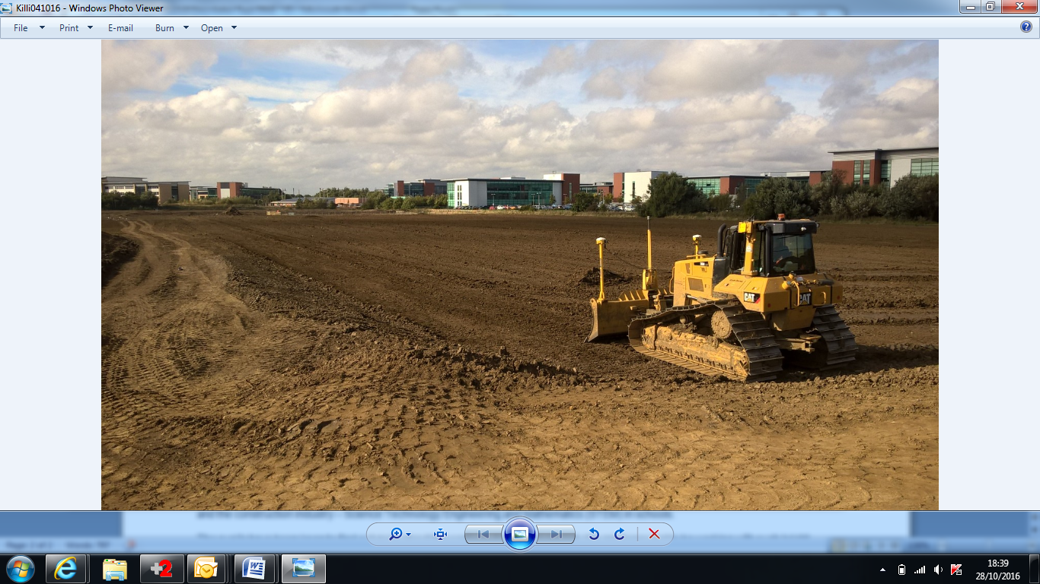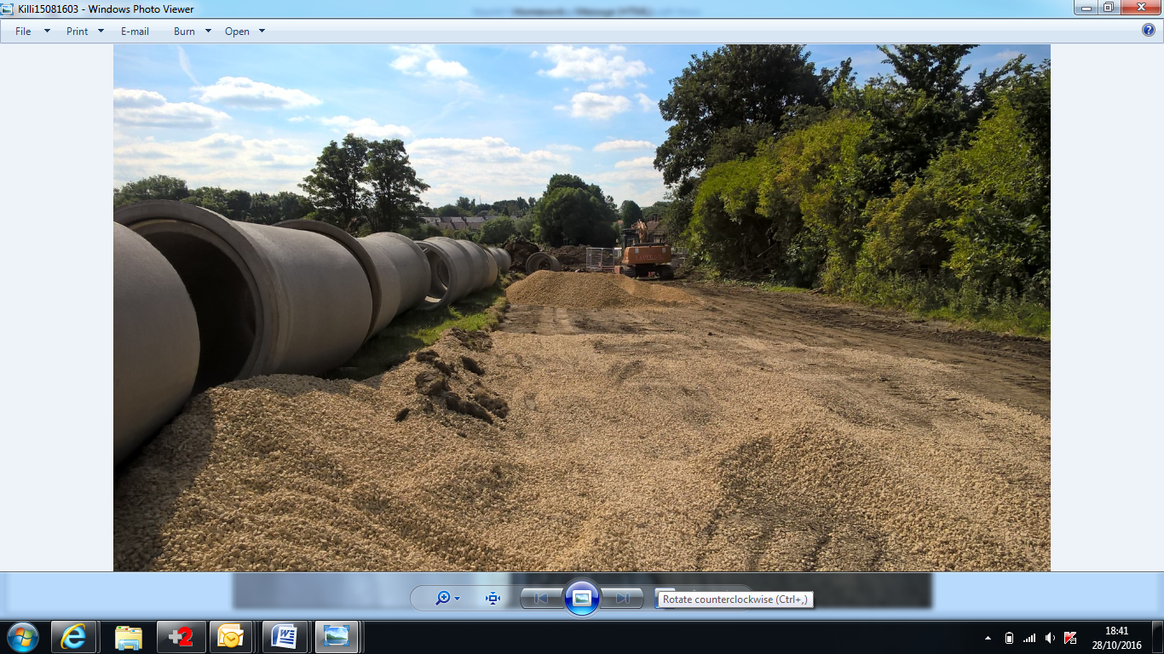

COMING NEXT
Please note that this programme may be subject to change as a result of progress, site conditions and weather:

AREA OF WORK | START DATE | END DATE | ADDITIONAL INFORMATION
Benton Cemetery | Autumn 2017 | This phase is expected to run for 20 weeks | We need to construct the inlet at the cemetery; the timescales for this are dependent upon the completion of the next stage of work in the area. Work is expected to start in Autumn 2017
Benton Village Green | November 2016 | Spring 2017 | Village Green Reinstatements – please see the plan and drawings on page 3 for further information on the proposals. Proposals have been discussed with Northumbrian Water, ESH-MWH, and The Friends of the Village Green during the Consultation Event. The reinstatements will be completed by Spring 2017.

PUBLIC CONSULTATION EVENT

We held a Public Consultation Event at Benton Dene Primary School on Thursday 22 September 2016, where we were able to show our plans for the reinstatement works on the Village Green. For those who were unable to attend, the images below show how we intend to leave the Village Green when we finish the work:

Above: Proposed views of Benton Village Green after completion of reinstatement work

COMMUNITY NEWS
In the last few months we have been fortunate to spend time with the pupils at Benton Dene Primary School, helping them learn about the importance of this type of project, health and safety on construction sites, designated pedestrian routes and also encouraging future careers in Civil Engineering and the construction industry – Science Technology Engineering and Mathematics (STEM) in schools.

The pupils have been keen to find out more about the work we do and this project. We are honoured to be working with such bright young people.

We also held a poster competition for the pupils to design some ‘Construction Safety’ related posters. The winning poster was blown up and printed and is now displayed on the fencing around the site and the runners up are all laminated and displayed in the site cabins. The winner and two of the runners up pictures are shown below:

Winner: Katie M Runners up: Milly, Polly, Madeline and Alyssa

OUR COMMUNITY PORTAL
Our community portal page for Killingworth & Longbenton is a great way to keep up to date about our progress. Please visit www.nwlcommunityportal.co.uk and click on the ‘Killingworth & Longbenton’ project for news, traffic information and downloadable project information.
Please be advised that you will be unable to contact the team via our portal on weekends or bank holidays. Please follow the guidance below on what to do outside of normal working hours if you need to speak with us.
CONTACT US
If you have any site related issues during weekends and bank holidays please contact the ESH-MWH ‘Out of Hours' team on 07890111222. Alternately please call Northumbrian Water’s customer centre on 0345 717 1100 or visit www.nwl.co.uk to chat online. You can also follow Northumbrian Water on twitter @nwater_care and @NorthumbrianH2O.
Please talk to us about any site related questions or concerns during the course of this work. We often resolve issues more effectively if we can discuss them with you first.
BOGUS CALLERS
Please be aware that bogus callers, people who claim to be employed by Northumbrian Water or ‘the water board’, but who are only interested in stealing from your home, are known to operate in our supply area. All our employees carry official identity cards which we strongly advise you to check before letting anyone into your home. If you are in any doubt about the validity of a caller claiming to be from Northumbrian Water do not let them into your property. Call the police immediately to report this, or our customer centre on 0345 717 1100 to confirm they are genuine.
Thank you for your patience and understanding throughout the course of this essential work.

