Our Ref: SN020/0208/Tallie 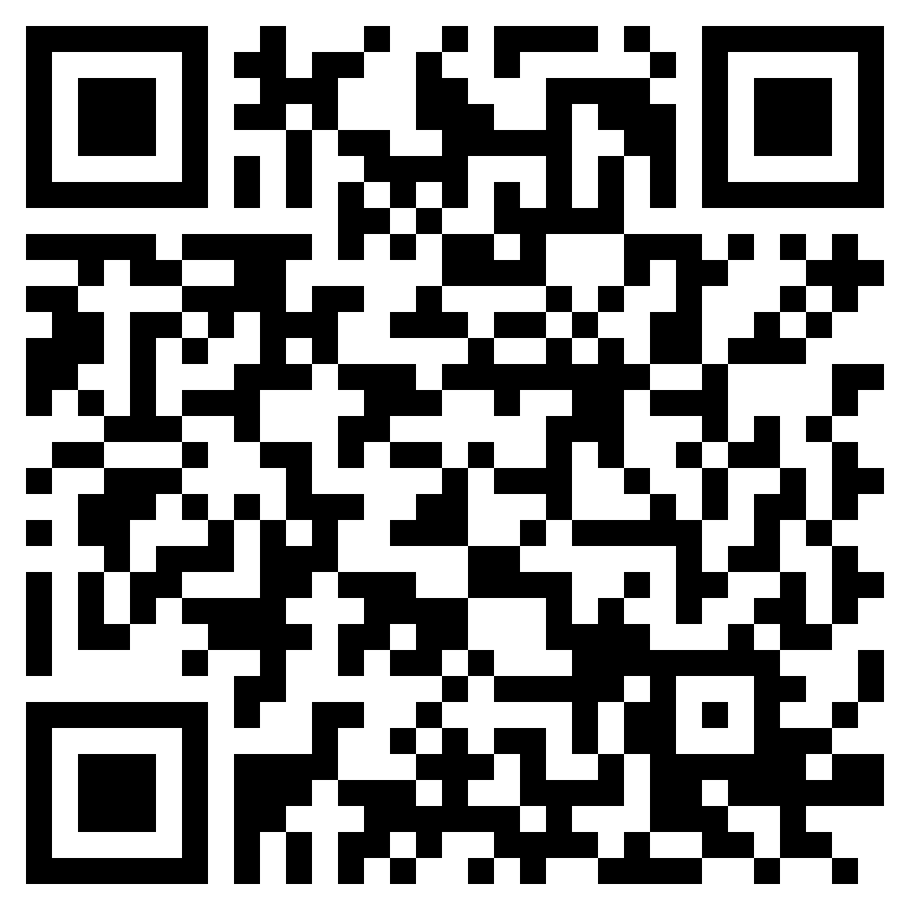

11 December 2023

Dear Customer

Update on the works in your area

I wanted to provide you with an update on the progress of the work being carried out on our behalf by Mott McDonald Bentley to reduce the risk of flooding. Firstly, I want to express my sincere gratitude for your patience and understanding throughout this crucial work.

As you may know, we are currently working in the highway at Bates Avenue, which has resulted in the temporary closure of the road. However, I am pleased to inform you that the road will be reopened before Christmas, with our target date set for 15 December 2023. We understand the inconvenience this closure has caused and we truly appreciate your understanding. The team will stop working for the Christmas break and will be off site between Thursday 21st December and Monday 1st January.

Additionally, I would like to inform you that the original estimated completion date of 31 May 2024 is likely to be extended and we now hope to complete the work by 30 August 2024. However, I want to assure you that the majority of the remaining work in the New Year will be focused on our Sewer Pumping Station near Crawford Street. We are committed to minimising any inconvenience caused to local residents and will make every effort to keep disruptions to a minimum.

Thank you once again for your understanding and cooperation as we continue our efforts to improve the flood risk in the area. If you have any questions or concerns, please do not hesitate to reach out to us.

You can also find out more information about our project on our community portal at www.nwlcommunityportal.co.uk and following the link to the Blyth-Bates Avenue page or via the QR code at the top of this letter. Once underway regular updates will be posted.

If you would like to speak to a member of our Project Team, you can telephone our customer contact centre on 0345 717 1100 or tweet us @nwater_care. Whichever way is best, we’d really like to hear from you.

Yours faithfully

Colin Short
Project Manager

Please be aware that bogus callers, people who claim to be employed by Northumbrian Water or ‘the water board’, but who are only interested in stealing from your home, are known to operate in our supply area. All our employees carry official identity cards which we strongly advise you to check before letting anyone into your home.

If you are in any doubt about the validity of a caller claiming to be from Northumbrian Water do not let them into your property. Call the police immediately to report this, or our customer centre on 0345 717 1100 to confirm they are genuine. Our employees will not object to waiting outside while you carry out these checks. For extra peace of mind customers can register a password with us – if we need access to your home we will know and use this word.

