Our Ref: WN016/0142

1 November 2017

Dear Customer

We’re planning some work in your area

At Northumbrian Water we are investing millions of pounds in our water network in Northumberland, North Tyneside, Newcastle and Gateshead. We are working with our construction partners ESH-MWH to install 22 electronically controlled valves (ECV’s) at strategic locations. This work will help to maintain a high quality and reliable water supply into the future.

As part of this work, ESH-MWH are planning to install an ECV and communication kiosk in Church Road on behalf of Northumbrian Water. This work is planned to start on Monday 6 November 2017.
At the junction of Church Road and Church Avenue traffic lights will be in place from Monday 13 November 2017 to Friday 23 February 2018. I have enclosed a map detailing the location of the traffic management for your information.
In an attempt to minimise any disruption, the traffic lights on Church Road will be sensor controlled to allow traffic to exit only when required. If no traffic is waiting to exit from Church Road the traffic lights here will remain red.
All traffic management will be removed by Friday 22 December 2017 ahead of the Christmas and New Year break and will be reinstalled from Monday 8 January 2018 to Friday 23 February 2018. This section of work is scheduled for seven weeks although ESH-MWH site team will endeavour to complete the work as early as possible.
We thank you for your understanding and co-operation throughout this work. If you require any further information or advice, now or during the work, please contact our Customer Centre on 0345 717 1100 or tweet us @nwater_care to request a call back from the Project Team.
You can also find out more information about this project and receive regular updates on progress and traffic management whilst works are in progress on our community portal at www.nwlcommunityportal.co.uk and following the link to the Tyneside Water Network Improvements page. Thank you for your patience and understanding while we carry out this work.

Yours sincerely
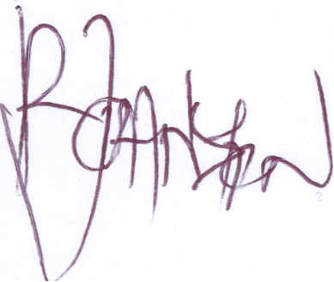

Richard Johnston
Project Manager

Please be aware that bogus callers, people who claim to be employed by Northumbrian Water or ‘the water board’, but who are only interested in stealing from your home, are known to operate in our supply area. All our employees carry official identity cards which we strongly advise you to check before letting anyone into your home. If you are in any doubt about the validity of a caller claiming to be from Northumbrian Water do not let them into your property. Call the police immediately to report this, or our customer centre on 0345 717 1100 to confirm they are genuine.

Our employees will not object to waiting outside while you carry out these checks. For extra peace of mind customers can register a password with us – if we need access to your home we will know and use this word.

